**Computer Organization and Assembly Language** (CS235)

END SEMESTER PROJECT

**GROUP MEMBERS**

* Abdul Basit (193227)
* Muhammad Asim Noor (140970)
* Muneeb Ishaq (153404)

**Submitted to**: Sir Taufique-ur-Rehman

**Dated**: January 8, 2018.

**Project Title:**

# “In-Sync Adaptive Traffic Control System”

**Problem**

The Basic problem we highlighted in this problem is the typical traffic control system we see in our daily life. These typical traffic control lights work on a simple algorithm in which every signal is given a fixed time for which it turns green, whether there is traffic or not. Other traffic users have to wait until this fixed time is over for no reason, resulting in more traffic jam and waiting more for the turn.

What we observed is that there is no signal light for the pedestrian, so a person does not know when it is safe for a person to walk or not

**Solution**

What we did is we created an algorithm that checks by using a IR tracking sensor the presence or motion of cars on the road, so if there is no flow of traffic on the road the sensor will simple turn the single red without waiting for the time to complete and will transfer the time to the next signal, and the same will continue for all the signals .so in this case a loop will complete in exactly 4 minutes (given a signal 60 seconds each). Once the loop completes it will turn the time transferred to next signal to zero.

**Advantage**

1. Better traffic control system
2. Safety for the pedestrians
3. Probability for the traffic jam decreases

**Implementation Details**

We used the Arduino UNO as a microprocessor, sensor for the traffic motion is IR tracking sensor. That sense the motion of cars on the road, We used RGB LED for the traffic lights, and a simple blue LED for the pedestrian Light, button has been used in the circuit, so basically our circuit ill not work until the button is pressed that means that this traffic system can be turned on and off when ever wanted.

**Model:**

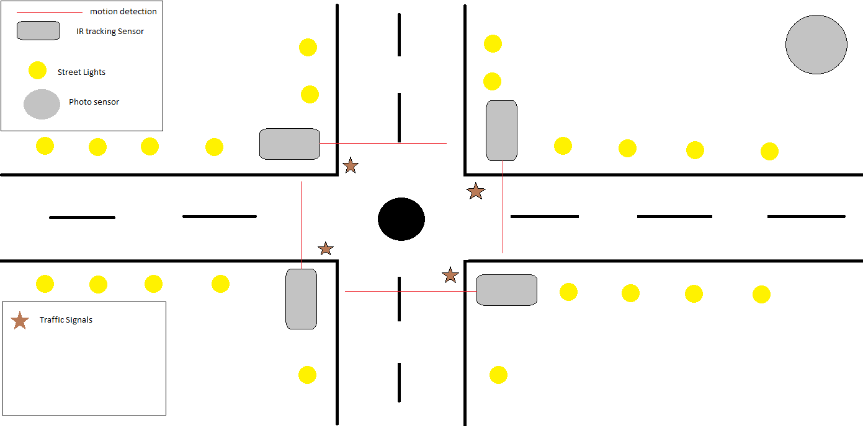

**Circuit Diagram:**

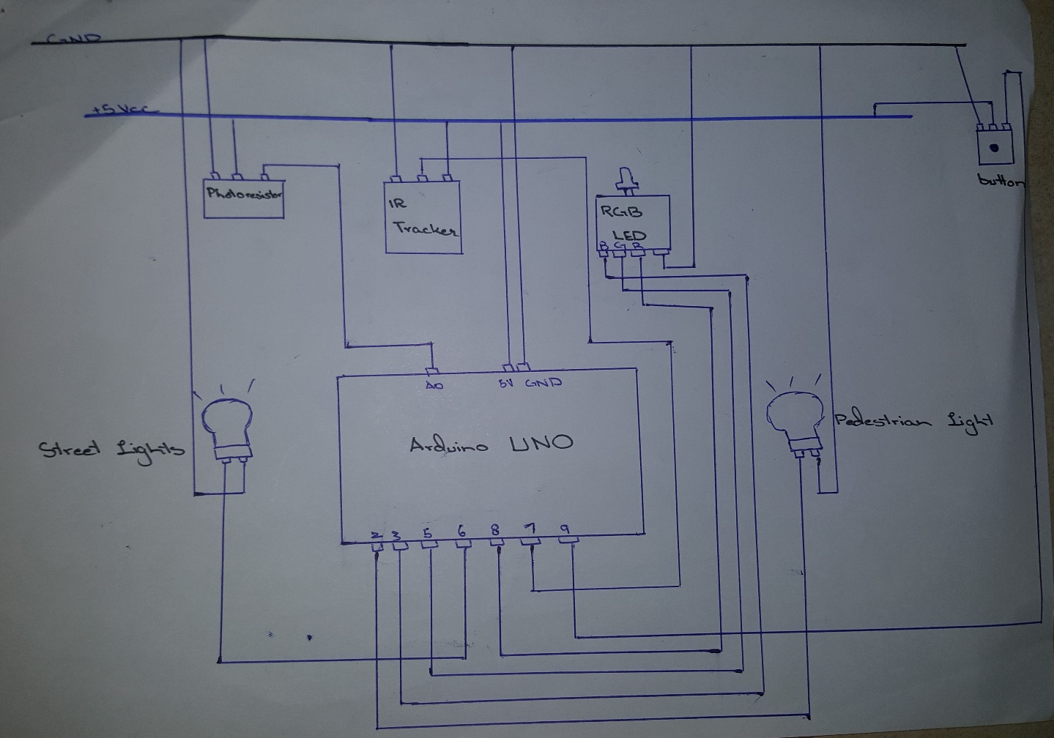

**Arduino Code:**

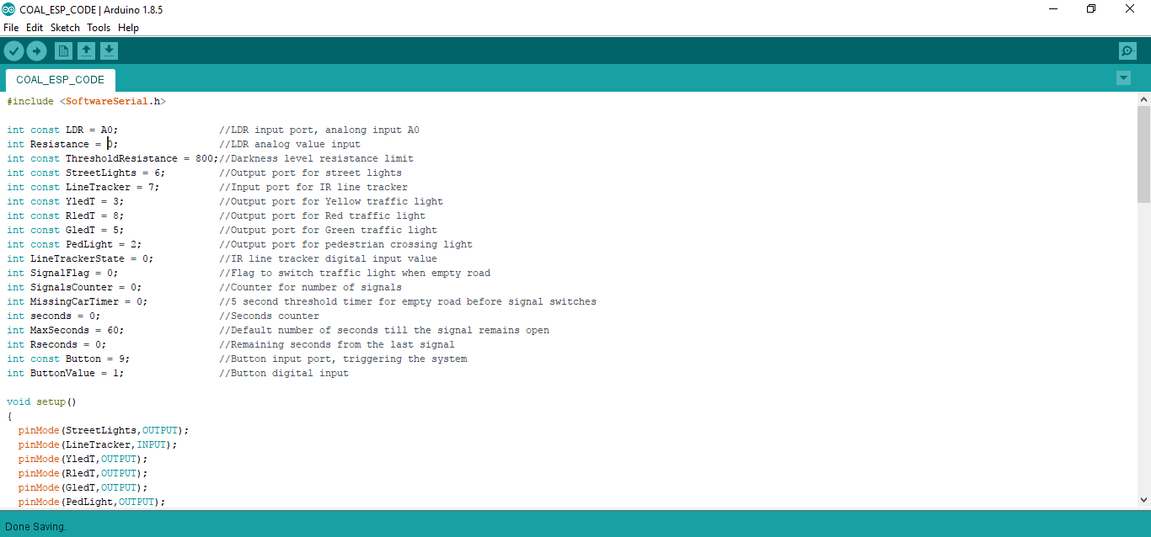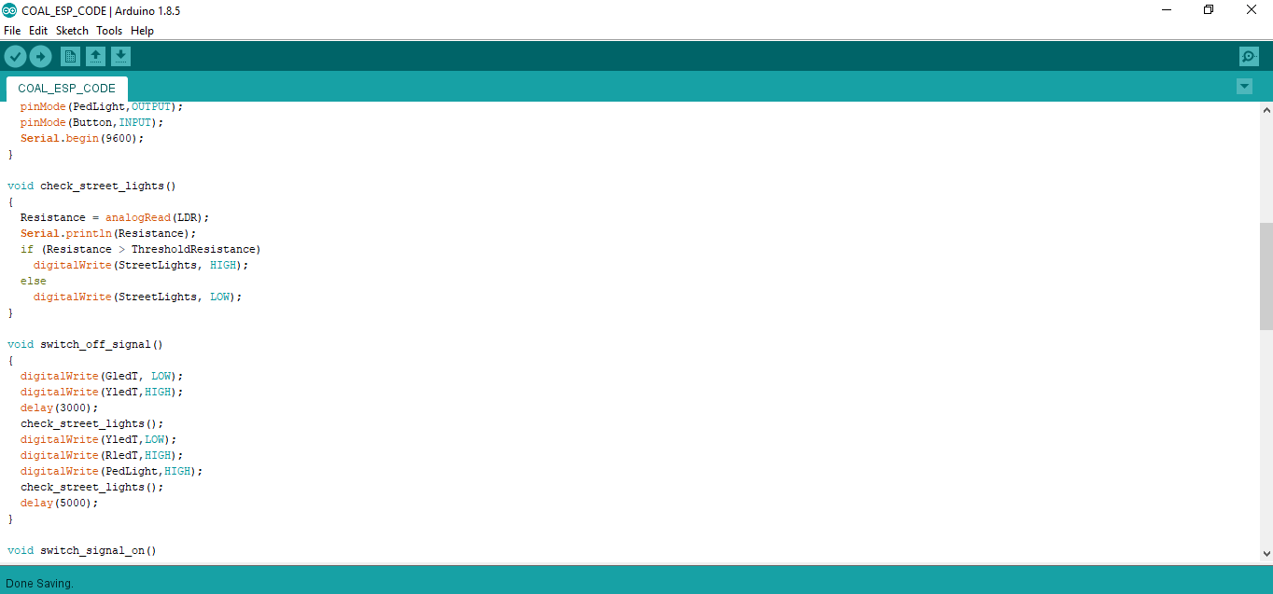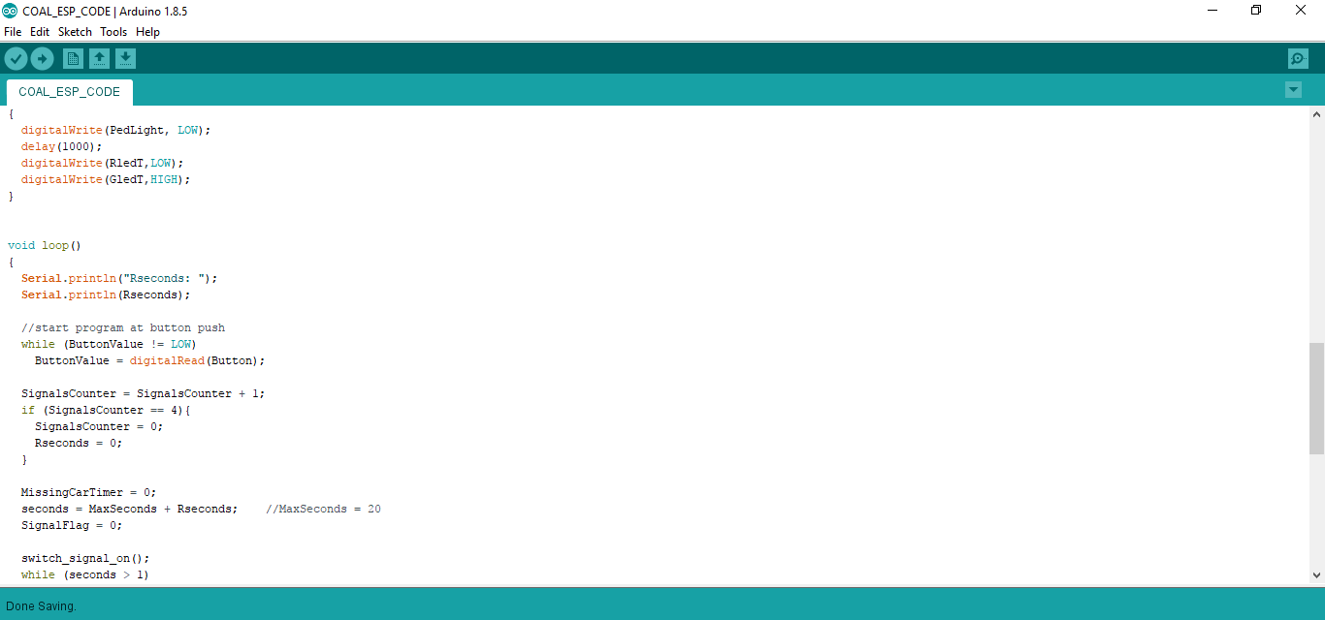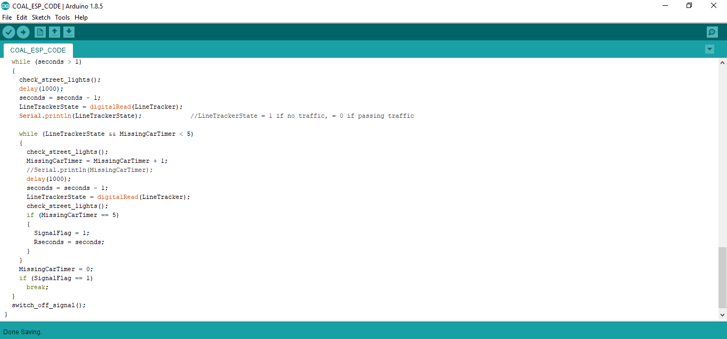

**Project Status**

Everything implemented as told in the proposal with some new and improved advancements.

**Work Divided:**

All the team members worked equally and together.

**What’s New???**

We added street lights just for a little advancement along with a pedestrian Light, street lights works with a photo resistor that checks the intensity of light and turns on or off the lights according to the intensity of light.

**Constraints**

The only difficulty we are facing is that the sensor we used is an Infra-red sensor that detects the body heat. So in case a pedestrian stands in front of the sensor it will detect its presence hence looping after completing whole time.

**Future Advancements**

Use of better sensors that can differentiate between a pedestrian and motor vehicle.

**Process Flow:**

IR Sensor

detects the

motion of cars

If car motion stops and

actual time of signal is

not completed then the

remaining time is added

to the next signal

Cycle

continues in

its order and

automated

system keeps

working

**SNAPSHOTS OF WORKING PROJECT:**

Green Light:

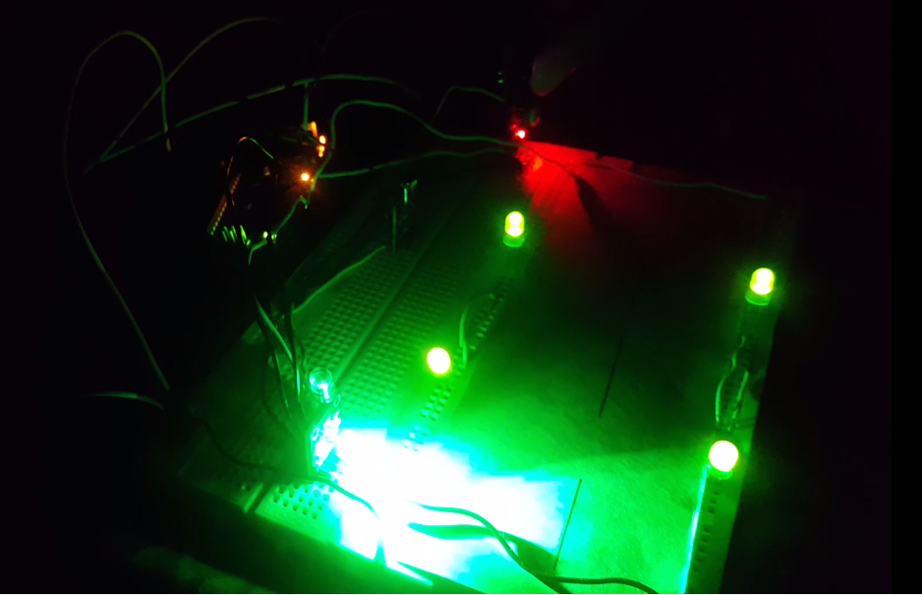

**Blue Light as Yellow Light:**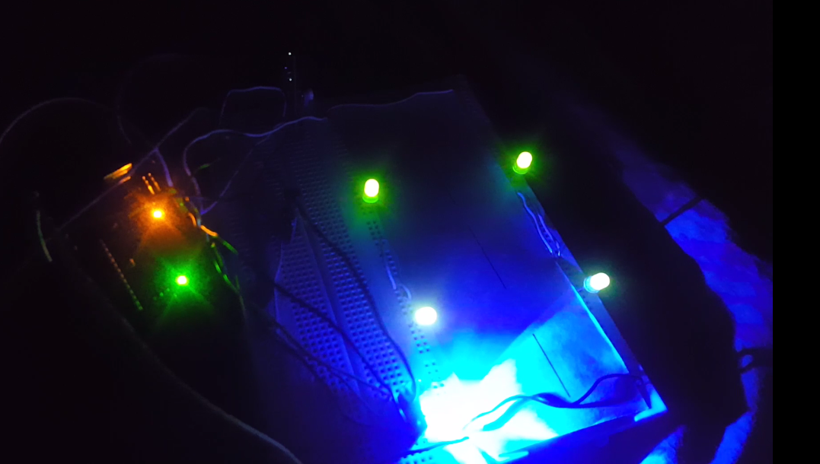

The Road:

